### Projects 6-15

### 

### Projects 6-16

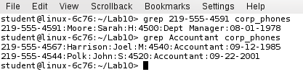

### sh EmployeeReport

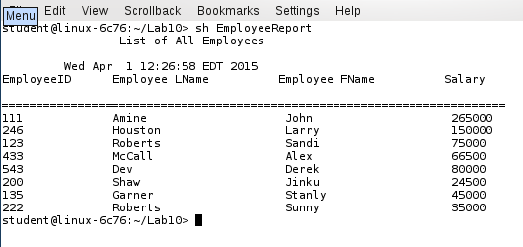

### sh Emp_Dept_Report

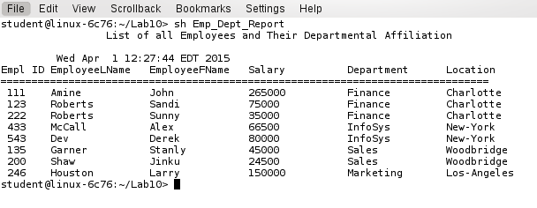

### sh Emp_Dept_Pos_Report

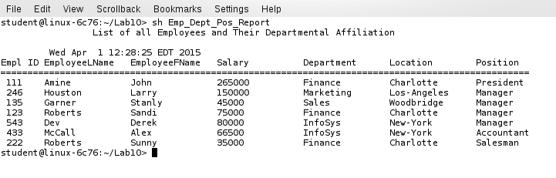

### sh Emp_Dept_Pos_SelectedReport

